Smart Garbage Management System Using IoT

* **Introduction :**

The idea struck us when we observed that the garbage truck use to go around the town to collect solid waste twice a day. Although this system was thorough it was very inefficient. For example let's say street A is a busy street and we see that the garbage fills up really fast whereas maybe street B even after two days the bin isn't even half full. This example is something that actually happens thus it lead us to the ''Eureka'' moment! 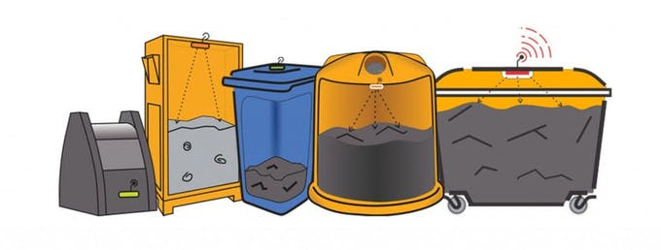

What our system does is it gives a real time indicator of the garbage level in a trashcan at any given time. Using that data we can then optimize waste collection routes and ultimately reduce fuel consumption. It allows trash collectors to plan their daily/weekly pick up schedule.

* **Criteria :**

The basic Model works like this:

To start with you will first have to know that there are three sensors in the dustbin. This will help us generate the percentage of trash in the garbage bin. We then have two criterias which needs to be satisfied to show that the particular bin needs to be emptied :

* The amount of trash, in other words let's say if your bin is half full you don't really need to empty it. Our thresh, or maximum amount that we permit of trash, is 100% of the bin. (You could alter the thresh according to your preference.)
* If supposing a particular garbage bin fills up 20% and then for a week doesn't change, it comes into our second criteria, time. With time even the little amount will start rotting leading to a smelly surrounding. To avoid that our tolerance level is 2 days, so if a garbage bin is less than 100 % but it is two days old it then will also need to be emptied.
* **Methodology :**
* At the Actual System there are IR sensor will be placed on the interior side of the garbage bins, the one facing the solid waste. As trash increases, then the IR sensor detects it. This live data will be sent to our micro- controller.
* Micro- controller then processes the data and sends to MQTT Cloud with the help of NODE MCU ESP 8266 Module, and also displays it to LCD module connected to it.
* At the Control Station there is a NODE MCU ESP 8266 which recieves the data from the MQTT Cloud and displays it ot the LCD module connected to it.

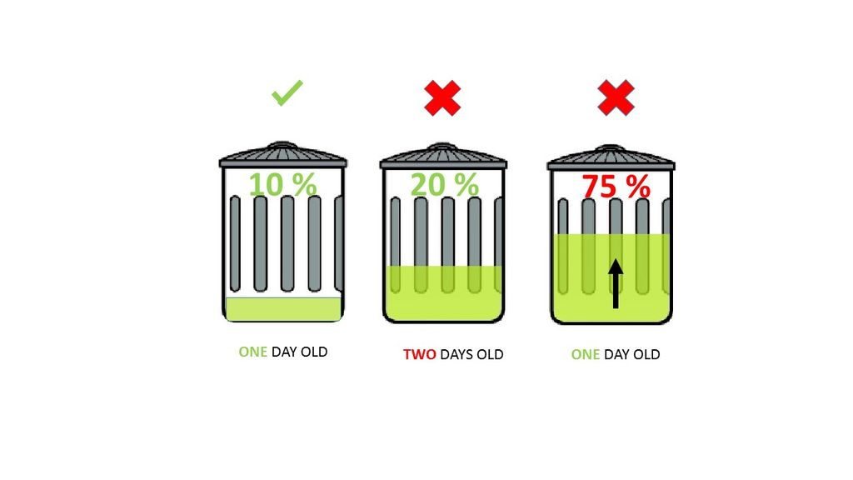

* **Block Diagram :**

**The Actual System :**

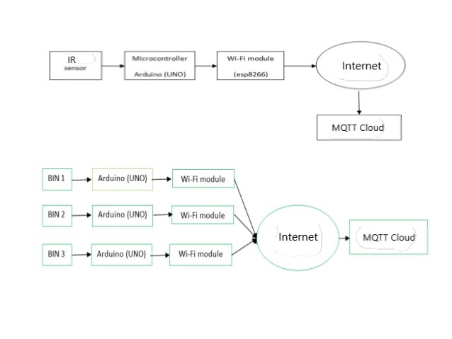

**The Control Station :**

